

KENNEDY ROAD, NEAR R.T.O., PUNE 411001

**Institute Code: 0141**

Academic Year: 2023-24

**Design Normalized Database for Blood Bank**

Program Code :CO3I

Course Name : **Data Base Management System [DMS]**

Course Code : 23319

Submitted by:

|  |  |  |  |
| --- | --- | --- | --- |
| **Roll No** | **Student Name** | **Branch** | **Enrollment Number** |
| 1525 | Shubham Dinesh Giri | SYCO | 2201410262 |
| 1526 | Rushi Raviraj Gujarathi | SYCO | 2201410263 |
| 1527 | Param Bhimrao Jadhav | SYCO | 2201410267 |

**Under Guidance of:**

Mr.S.Y.Divekar

# ALL INDIA SHRI SHIVAJI MEMORIAL SOCIETY’S POLYTECHNIC, PUNE -1

**COMPUTER ENGINEERING DEPARTMENT**

**VISION AND MISSION OF THE INSTITUTE**

* **VISION:**

“Enhance skills by providing value based technical education for fulfilling global needs in the field of computer engineering.”

* **MISSION:**
* To provide quality education in computer engineering by improving psychomotor skills.

* To develop positive attitude, communication skills, team spiritand entrepreneurship.

* To develop awareness about societal and ethical responsibility for Professionalism.

**VISION AND MISSION OF THE COMPUTER DEPARTMENT**

**VISION:**

“Enhance skills by providing value based technical education for fulfilling global needs in the field of computer engineering.”

**MISSION:**

**M1**: To provide quality education in computer engineering by improving Psychomotor skills.

**M2**: To develop positive attitude, communication skills, team spirit and entrepreneurship.

**M3**: To develop awareness about societal and ethical responsibility for Professionalism.

# ALL INDIA SHRI SHIVAJI MEMORIAL SOCIETY’S POLYTECHNIC, PUNE -1

# COMPUTER ENGINEERING DEPARTMENT

|  |  |
| --- | --- |
|  |  |
|  | **PROGRAM OUTCOMES (POs)** |
| **PO1** | **Basic and Discipline specific knowledge:** Apply knowledge of basic mathematics, science  and engineering fundamentals and engineering specialization to solve the engineering problems.. |
| **PO2** | **Problem analysis:** Identify and analyze well-defined engineering problems using codified  standard methods. |
| **PO3** | **Design/ development of solutions:** Design solutions for well-defined technical problems and  assist with the design of systems components or processes to meet specified needs. |
| **PO4** | **Engineering Tools, Experimentation and Testing:** Apply modern engineering tools  and appropriate technique to conduct standard tests and measurements. |
| **PO5** | **Engineering practices for society, sustainability and environment:** Apply appropriate technology in context of society, sustainability, environment and ethical practices. |
| **PO6** | **Project Management:** Use engineering management principles individually, as a team member  or a leader to manage projects and effectively communicate about well-defined  engineering activities. |
| **PO7** | **Life-long learning:** Ability to analyze individual needs and engage in updating in the context  of technological changes. |

**PROGRAM SPECIFIC OUTCOMES (PSO)**

The Diploma in Computer Engineering will prepare students to attain:

**PSO 1:** Apply computing knowledge with standard practices to develop software. • **PSO 2:** Maintain Computer Hardware and Software System.



**Institute Code: 0141**

**CERTIFICATE**

This is to certify that micro project entitled “Design Normalized Database for Blood Bank” has been completed under **Course: Data Base Management System Course code:23319** for the second year diploma in Computer Engineering Department Batch 2023-23. The members of the team:

|  |  |  |
| --- | --- | --- |
| 1. Shubham Dinesh Giri | 2. Rushi Raviraj Gujarathi | 3. Param Bhimrao Jadhav |

**Mrs. S. Y. Divekar**

**(Name & Signature of faculty)**

**COs addressed by the Micro Project:**

**C23319.1**: Design Normalized database on given data.

**C23319.2**: Create and Manage Database using SQL command.

**C23319.3**: Write PL/SQL code for given database.

**C23319.4**: Apply Exception on database.

**C23319.5**: Apply security and confidentiality on given Database.

**Major Learning Outcomes achieved by students by doing the micro project:**

1. **Practical Outcomes:** 
   * Design E-R diagram and Create Normalized Database on given.
   * Create and Execute DDL commands using SQL.
   * Apply Integrity constraints on table.
   * Create and Execute DML commands using SQL.
   * Write Queries using operators.
   * Create and Execute View, Indexes, Sequences, and synonyms in SQL.
   * Write a PL/SQL programs.
   * Write a PL/SQL code to implement implicit and explicit cursors.
   * Write PL/SQL code to create Procedures, functions and Trigger.
   * Executing DCL commands using SQL.
2. **Unit Outcomes in Cognitive domain** 
   * Draw the E-R diagram of the given Relational.
   * Design Normalized database structure in the given problem.
   * Identify the operators for queries implementation of the given problem.
   * Write the given queries using relevant functions.
   * Design SQL queries to implement VIEW, INDEX and SYNONYM.
   * Write PL/SQL code using control structure.
   * Create and execute cursor, store procedure, function and apply trigger using PL/SQL.
   * Provide security to the given database by assigning various privileges to the users.
3. **Outcomes in Affective Domain** 
   1. Follow safety practices.
   2. Practice good housekeeping.
   3. Demonstrate working as a leader/a team member.
   4. Maintain tools and equipment.
   5. Follow ethical practices.

**ACKNOWLEDGEMENT**

We are deeply indebted to our project guide Mr. S. Y. Divekar for guiding us in a proper way in order to complete our micro project. We would like to express our gratitude towards our guide for her valuable guidance, suggestion, and continues support throughout in preparing the short-term training report.

We also express our thanks to our seniors for their great support and suggestions.

**INDEX**

|  |  |  |
| --- | --- | --- |
| **Sr. No.** | **Content** | **Page No.** |
| 1. | Micro Project Proposal (Annexure –I) | 8-10 |
| 2. | Micro Projects Report (Annexure –II) | 11-21 |
| 3. | Assessment of Micro Project (Annexure –III) | 23-23 |
| 4. | Micro Project Evaluation Sheet (Annexure –IV) | 24-27 |
| 5. | Log Book | 28 |

**Introduction**

To create a system for connecting every blood bank or a donor in a chain so that this chain can be beneficial for patients who are in dire need of blood. The objective of developing such a system is to eliminate the situation of havoc and panic in cases of emergencies, so that the patient's family can stay besides each other rather than rushing for arranging blood.

The beauty of this system is that a user can both ask for blood and be a donor. The user can keep donating on regular basis and keep updating on the app for it to inform when the next time the user is eligible for donation is. Blood bank storage and management involves keeping records of blood available as well as information regarding the donors of the blood and also hospitals and patients that are in need of the blood.

Blood donation is a very delicate process and therefore, it should be managed and controlled with high caution. This means that data and information regarding blood, donors and recipients are kept in spreadsheets, papers and files arranged in alphabetical or numeric order.

The process of retrieving blood, donor or recipient information is a tedious process and takes a lot of time. Considering the hospitals' and recipients' needs and the urgency usually involved, this makes it hard for the hospitals and put the recipient's life in danger. Data Safety, security and backup is also poor as the papers and files can be easily stolen, lost or destroyed. This makes it an unreliable system.

There are six departments created in existing database. They are as follows: Doctor, Donor, Blood Bank, Blood, Patient and Blood Delivery. Computerized blood bank management system (BBMS) had been developed in previous years but are highly inadequate. The existing BBMS’s are mere storage systems that are mostly unusable by the hospital workers. They focus more on storage rather than coordinating management and operational activities and therefore are still yet to be accepted by the establishments.

**ANNEXURE - I**

**Micro-Project Proposal**

## Design Normalized Database for Blood Bank

**1.0 Aims/Benefit of the Micro Project:**

**Aim:** Design Normalized Database for Blood Bank.

**Benefits:**

1. It provides the unique identification number at the time of blood donation camp which helps him/her for the future correspondence. It gives the unique user id and password for those donors who are applying online. They can edit their information time to time. This feature
2. helps administrator to collect the information of all the donor’s area wise and blood group wise.
3. Seeker can get the list of donors’ area wise, blood group wise if the desired blood group is not available in the central inventory.
4. Seeker can get the information of the particular blood group available in the blood bank.
5. Seeker can get the blood units according to his requirement from the blood bank.
6. The probability of error is minimal.
7. Information retrieval is precise and effective.

**2.0 Course Outcomes Addressed:**

1. **C23319.1**: Design Normalized database on given data.
2. **C23319.2**: Create and Manage Database using SQL command.
3. **C23319.3**: Write PL/SQL code for given database.
4. **C23319.4**: Apply Exception on database.
5. **C23319.5**: Apply security and confidentiality on given Database.

**3.0 Proposed Methodology:**

This Blood Bank system has realized the need of blood, so as to facilitate the management and decision of blood save, and reduce a big burden for doctor and patient.

It also can help to improve the work efficiency of blood delivery. Its requirements is to provide the basic information maintenance function of doctor and Blood delivery

so that doctor can through the function to add, delete, and modify the basic information of patient,donor and blood delivery can through it to add, modify and delete the basic information of

place of the blood store,patient address,donor address.

blood Bank system is very convenient for manage blood , and find the data like blood_store place so as to make the messy data to specific, visualizations, rationalization. In the aspect of database, the blood Bank system using Oracle as the background database

**4.0 Action Plan:**

|  |  |  |  |  |
| --- | --- | --- | --- | --- |
| **Sr. No.** | **Details of Activity** | **Planned Start Date** | **Planned**  **Finish**  **Date** | **Name of Responsible Team Members** |
| 1 | Formation of groups | 24-07-2023 | 24-07-2023 | Shubham Giri,Param Jadhav,Rushi Gujarathi |
| 2 | Selected the topic for micro project | 24-07-2023 | 24-07-2023 | Rushi Gujarathi |
| 3 | Discussed about the project | 01.08.2023 | 01.08.2023 | Shubham Giri,Param Jadhav,Rushi Gujarathi |
| 4 | Assigned the work to each group member | 07.08.2023 | 07.08.2023 | Shubham Giri,Rushi Gujarathi |
| 5 | Detailed study of micro-project | 14.08.2023 | 14.08.2023 | Shubham Giri,Param Jadhav,Rushi Gujarathi |
| 6 | Collected information on assignment topic | 21.08.2023 | 21.08.2023 | Shubham Giri,Param Jadhav,Rushi Gujarathi |
| 7 | Started working on micro- project | 28.08.2023 | 28.08.2023 | Shubham Giri,Param Jadhav,Rushi Gujarathi |
| 8 | Assembled all the data | 04.09.2023 | 04.09.2023 | Param Jadhav |
| 9 | Evaluation of data | 11.09.2023 | 11.09.2023 | Shubham Giri,Rushi Gujarathi |
| 10 | Prepared rough copy of micro- project | 18.09.2023 | 18.09.2023 | Param Jadhav, Shubham Giri,Rushi Gujarathi |
| 11 | Project proposal presentation to guide | 25.09.2023 | 25.09.2023 | Param Jadhav, Shubham Giri,Rushi Gujarathi |
| 12 | Corrected the micro-project suggested by guide | 02.10.2023 | 02.10.2023 | Rushi Gujarathi |
| 13 | Actual implementation of micro-project | 9.10.2023 | 9.10.2023 | Param Jadhav, Shubham Giri,Rushi Gujarathi |
| 14 | Execution of overall data / prepared final draft copy | 16.10.2023 | 16.10.2023 | Param Jadhav, Shubham Giri,Rushi Gujarathi |
| 15 | Final micro-project presentation | 23.10.2023 | 23.10.2023 | Param Jadhav, Shubham Giri,Rushi Gujarathi |
| 16 | Micro-project submitted | `30.10.2023 | `30.10.2023 | Param Jadhav, Shubham Giri,Rushi Gujarathi |

**5.0 Resource Required:**

|  |  |  |  |
| --- | --- | --- | --- |
| **S. No.** | **Name of Resources/ material** | **Specification** | **Remarks** |
| 1. | Computer/ Laptop | Any desktop or laptop with basic configuration | --- |
| 2. | Software | Oracle XE 10g, My SQL, SQL Live, Microsoft Word | --- |

**Name of Team Members with Roll No:**

|  |  |  |
| --- | --- | --- |
| **Sr. No** | **Name of Students** | **Roll No** |
| 1. | Shubham Giri | 1525 |
| 2. | Rushi Gujarathi | 1526 |
| 3. | Param Jadhav | 1527 |

**Mr. S. Y. Divekar**

**(Name & Signature of faculty)**

**ANNEXURE - II**

### Micro-project Report

**DESIGN NORMALIZED DATABASE FOR BLOOD BANK**

**1.0** **Rationale:**

To create a system for connecting every blood bank or a donor in a chain so that this chain can be beneficial for patients who are in dire need of blood. Blood Bank Management system will greatly increase the safetyand quality of the blood supply as well as provide logistics data for the optimal supply chain management.

The beauty of this system is that a user can both ask for blood and be a donor. Blood donation is a very

delicate process and therefore, it should be managed and controlled with high caution. Eliminating existing BBMS’s that are mostly unusable by hospital workers, this is a computerized system to reduce human errors and backup documents or human written files which also require huge storage.

**2.0 Aims/Benefits of the Micro Project:**

**Aim:** Design normalized database for blood bank.

**Benefits:**

1. It provides the unique identification number at the time of blood donation camp which helps him/her for the future correspondence. It gives the unique user id and password for those donors who are applying online. They can edit their information time to time. This feature helps administrator to collect the information of all the donor’s area wise and blood group wise.
2. Seeker can get the list of donors’ area wise, blood group wise if the desired blood group is not available in the central inventory.
3. Seeker can get the information of the particular blood group available in the blood bank.
4. Seeker can get the blood units according to his requirement from the blood bank.
5. The probability of error is minimal.
6. Information retrieval is precise and effective.

**3.0 Course Outcomes Achieved:**

**C23319.1**: Design Normalized database on given data.

**C23319.2**: Create and Manage Database using SQL command.

**C23319.3**: Write PL/SQL code for given database.

**C23319.4**: Apply Exception on database .

**C23319.5**: Apply security and confidentiality on given Database.

**4.0 Literature Review:**

|  |  |  |  |
| --- | --- | --- | --- |
| **Author / Publication** | **Title / Topic** | **Methods / Techniques used** | **Limitations** |
| Shubham Tomer,  Saurav Tomer,  Rohit S. Remella | A Review Paper on Blood Bank Management System | Efficient working of blood bank management system. | Cannot simplify and automate the process of searching for blood in case of emergency and maintain the records of blood banks. |
| Mohamed Ismail Z,  Tukur Anas  Mohammad,  Ibrahim Fawze Akar | CBBR Centralized Blood Bank Repository | 1. Manages the blood of all blood group types.  2. Stores secured information.  Manages donors as well as receivers.  3.Monitor the requests and proctor the attempts made at both ends. | Cannot Upload and Download the latest updates at right time.  Does not mention about the E-R diagram. |
| Dr. Sharad  Maheshwari, Vikas  Kulshreshtha | Benefits of Management  Information System in Blood  Bank | Easy to understand and follow to record people effectively and competently. | Blood donors and patients or recipients of blood donation are not system users, this registration information will be encoded by the receptionists. |

**5.0 Actual Methodology:**

Actual flow of data/Conceptual framework:

The database for to Blood bank system is mainly developed to manage a blood. So the structure of the database contains the tables related to the blood. The doctor table stores all the details of the doctors working in the Hospital. The table named donor is there to store the information related to donor_name. blood_bank table is used to store the details of blood [lace where the blood is store. .The blood_delivery table contain the data of patient who”s need the blood. There are some primary for building a relation within and among the tables. The use of Exception will be use here patient is present or not.Some PL/SQL codes are used here to insert and update data in the tables.

In this way, database for the blood bank system is created.

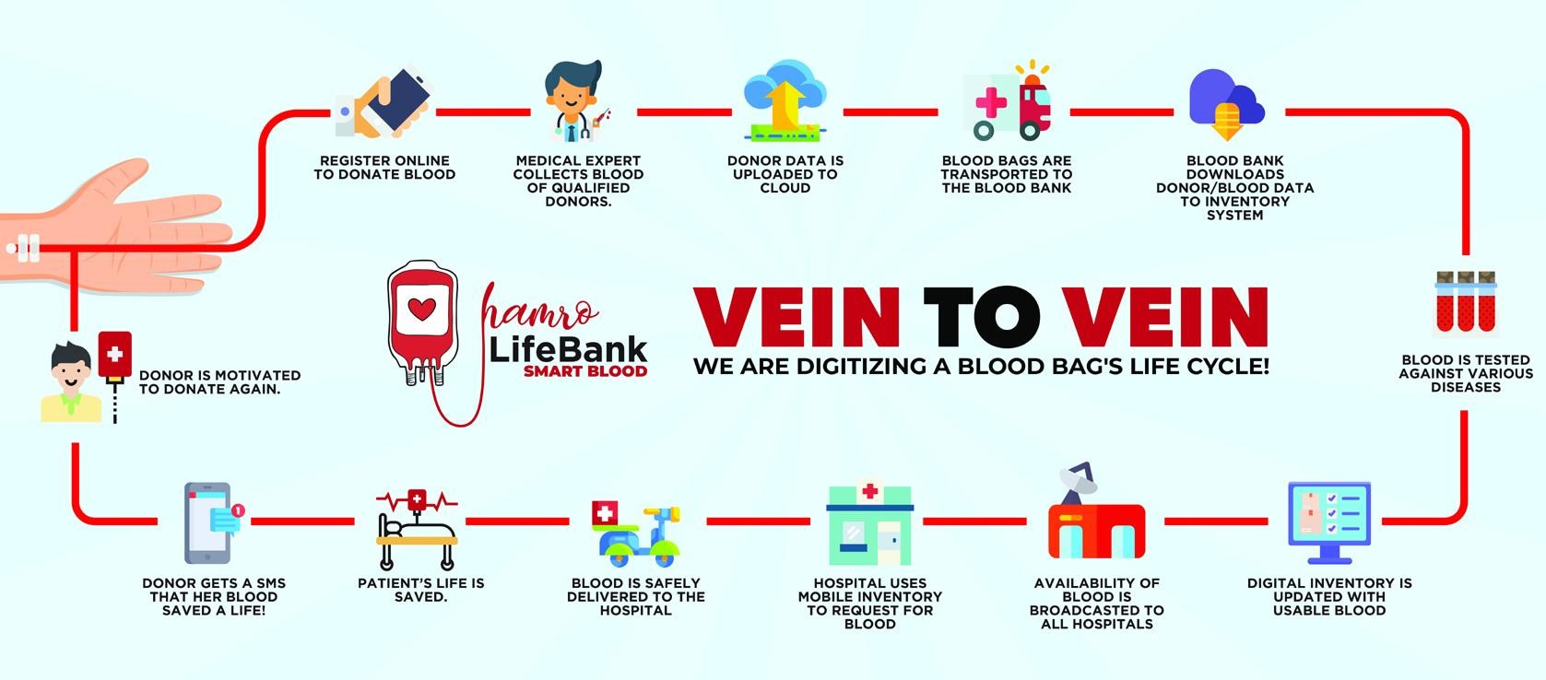

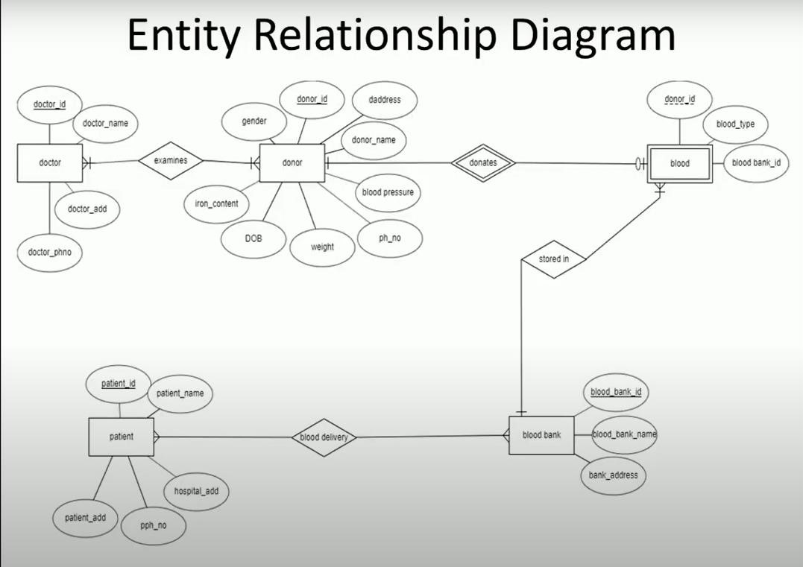

Normalized tables: **Doctor:**

|  |  |
| --- | --- |
| **Doc_id** | **Primary Key** |
| Doc_name |  |
| Doc_address |  |
| Doc_phone |  |

**Donor:**

|  |  |
| --- | --- |
| **Donor_id** | **Primary Key** |
| Donor_name |  |
| Donor_phone |  |
| Donor_DOB |  |
| Gender |  |
| Donor_address |  |
| Weight |  |
| Blood_pressure |  |
| Iron_content |  |
| Doctor_id | Foreign Key references Doctor_id of Doctor table. |

**Blood Bank:**

|  |  |
| --- | --- |
| **Bloodb_id** | **Primary Key** |
| Bloodb_name |  |
| Bloddb_address |  |

**Blood:**

|  |  |
| --- | --- |
| Blood_type |  |
| Donor_id | Foreign Key references to Donor_id of Donor table. |
| Bloodb_id | Foreign Key references to Bloodb_id of Blood Bank table. |

**Patient:**

|  |  |
| --- | --- |
| **Patient_id** | **Primary Key** |
| Patient_name |  |
| Patient_phone |  |
| H_address |  |
| Patient_address |  |

**Blood delievery:**

|  |  |
| --- | --- |
| Bloodb_id | Foreign Key references to Bloodb_id of Blood Bank table. |
| Patient_id | Foreign Key references to Patient_id of Patient table. |

**6.0 Actual Resource Required:**

|  |  |  |  |
| --- | --- | --- | --- |
| **S. No.** | **Name of Resources/ material** | **Specification** | **Remarks** |
| 1 | Computer/ Laptop | Any desktop or laptop with basic configuration | --- |
| 2 | Software | Oracle XE 10g, My SQL, SQL Live, Microsoft Word | --- |

**7.0 Outputs of the Micro project:**

**BLOOD BANK MANAGEMENT SYSTEM**

Some output:

User-system

Password-system

set serveroutput on;

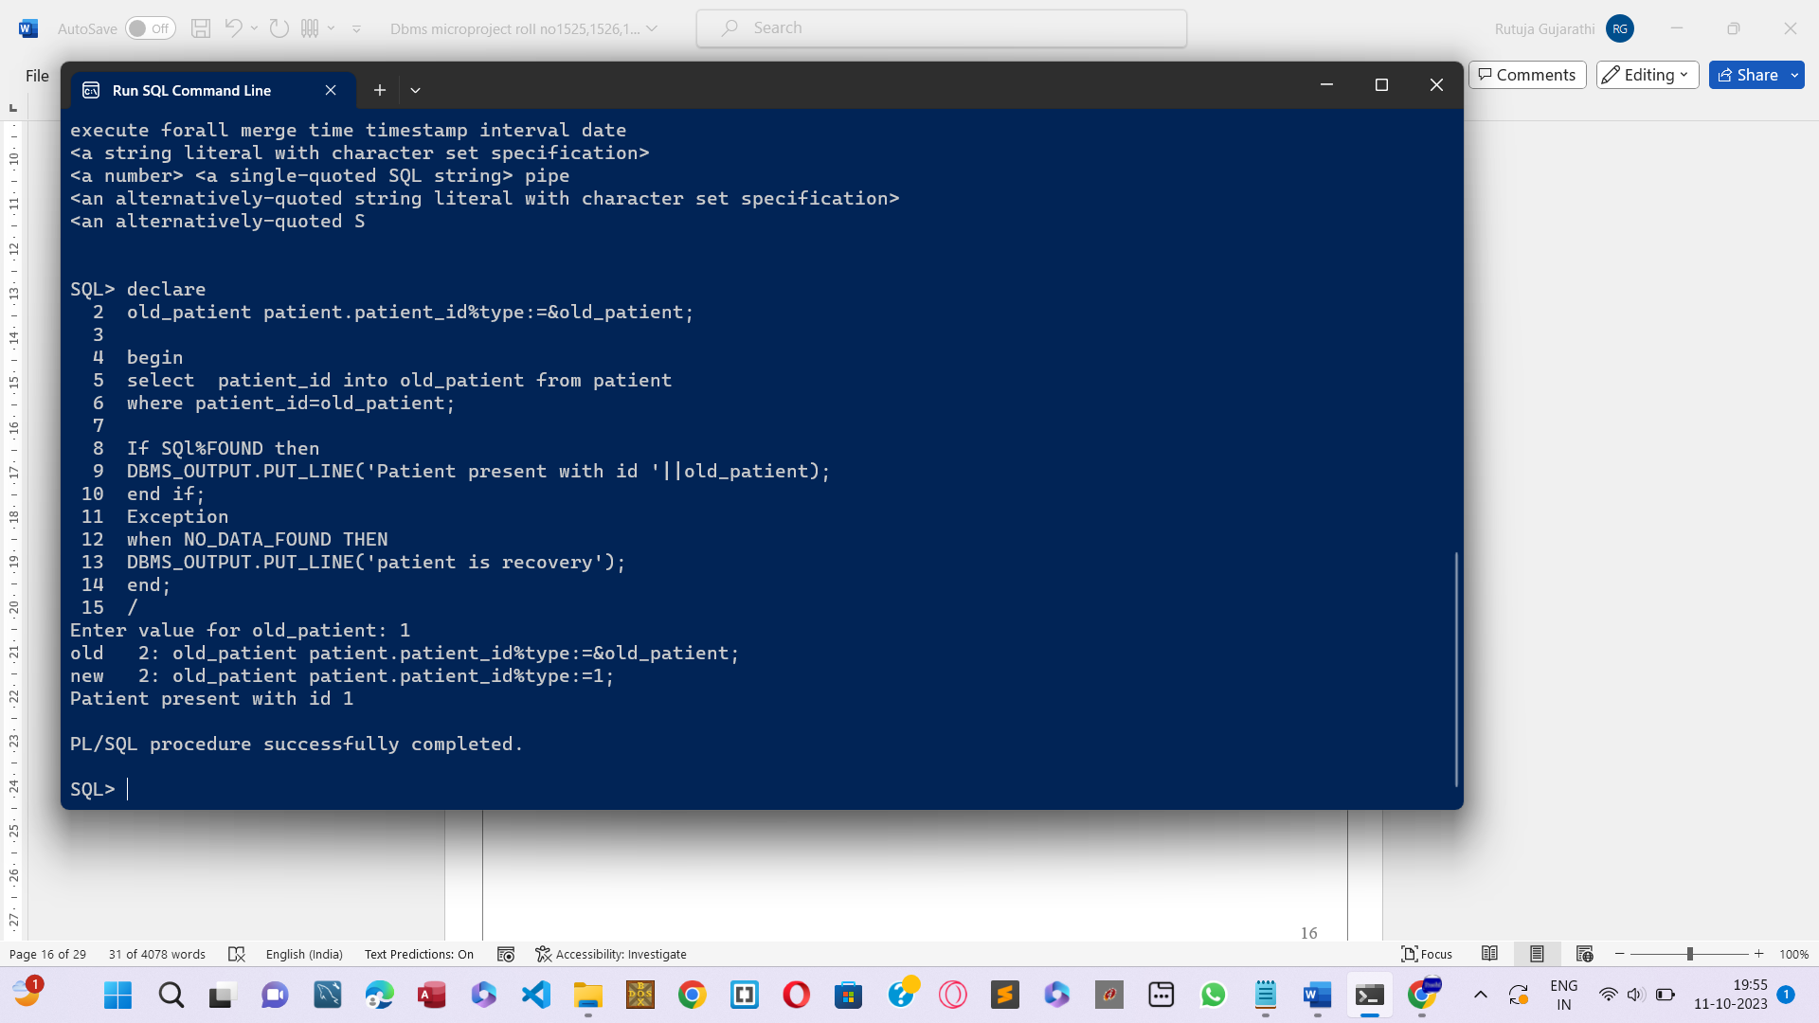This output is indicated that patient is present or not,

**TABLE 1: DOCTOR TABLE**

create table doctor

(doctor_id number(5) primary key, doctor_name varchar2(50), doc_add varchar2(50),

doc_phno number(10));

desc doctor;

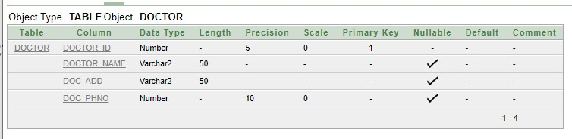

**DOCTOR TABLE WITH VALUES:**

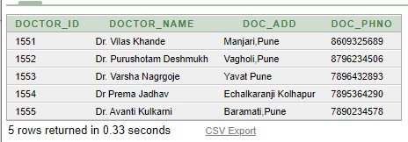

**TABLE 2: DONOR TABLE**

create table donor

(donor_id number(5) primary key, donor_name varchar(50), phone_no number(10), DOB date,gender char(1), address varchar(50), weight number(3), blood_pressure number(10), iron_content number(10)); doctor_id NUMBER(5),

FOREIGN KEY(doctor_id) REFERENCES doctor(doctor_id)); desc donor;

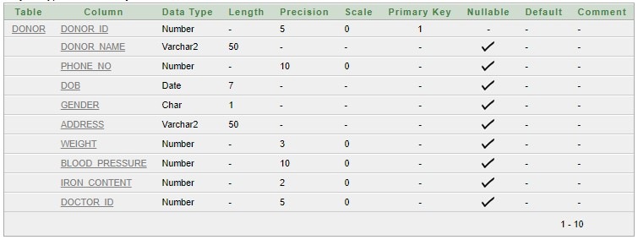

**DONOR TABLE WITH VALUES:**

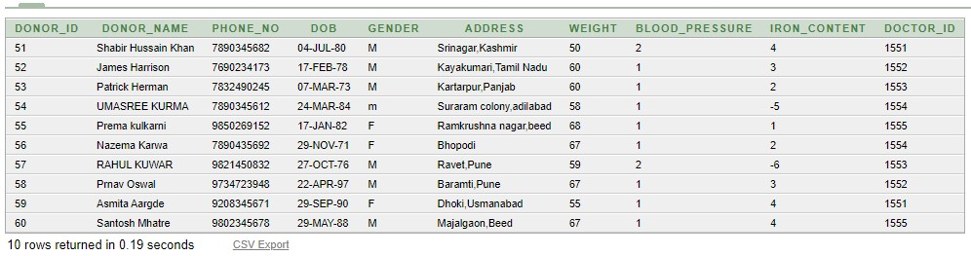

**TABLE 3: BLOOD TABLE**

create table blood (blood_type varchar(20), donor_id NUMBER(5), blood_bank_id NUMBER(5),

foreign key(donor_id) REFERENCES donor(donor_id),

foreign key(blood_bank_id) REFERENCES blood_bank(blood_bank_id)); desc blood;

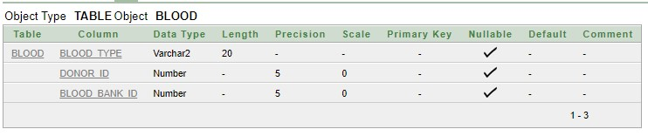

**BLOOD TABLE WITH VALUES:**

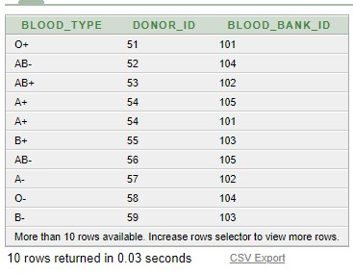

**TABLE 4: BLOOD BANK TABLE**

create table blood_bank

(blood_bank_id NUMBER(5) PRIMARY KEY,

blood_bank_name varchar(30),

baddress varchar(30));

desc blood_bank;

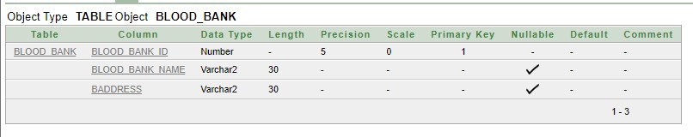

**BLOOD BANK TABLE WITH VALUES:**

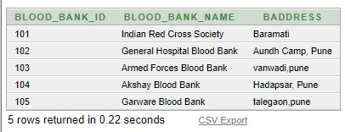

**TABLE 5: PATIENT TABLE**

create table patient (patient_id number(5) primary key, patient_name varchar(30),

p_phno number(10),

h_add varchar(50),

p_add varchar(50));

desc patient;

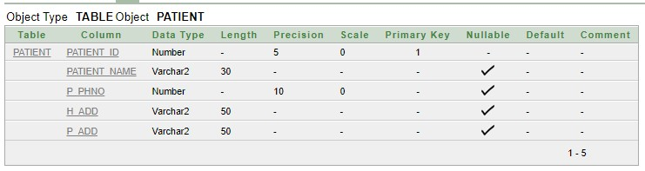

**PATIENT TABLE WITH VALUES:**

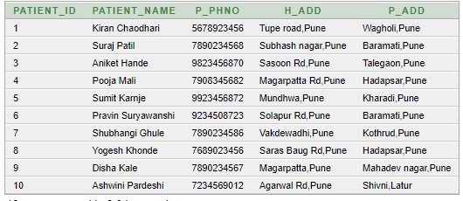

**TABLE 6: BLOOD DELIEVERY TABLE** create table blood_delivery (blood_bank_id number(5), patient_id number(5),

foreign key(blood_bank_id) REFERENCES blood_bank(blood_bank_id),

foreign key(patient_id) REFERENCES patient(patient_id)); desc blood_delivery;

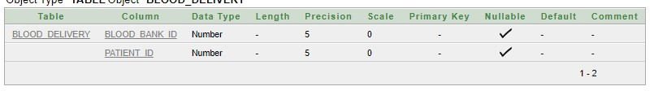

**BLOOD DELIEVERY TABLE WITH VALUES:**

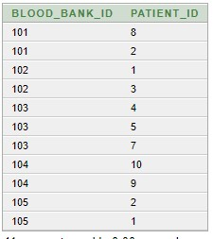

**8.0 Skill developed / Learning outcome of the Micro-Project:**

1. Gained the knowledge to use Oracle database effectively and learnt how to implement it for real time applications like developing blood bank database.
2. Developed the skills to searching authentic information, rearrange or assemble to build our project.
3. Working as a team, developing leadership capabilities.
4. Presenting information effectively.
5. Developed the skills of learning to create database with adequate amount of information and possible less time.

**9.0 Applications of the Micro-Project:**

1. Blood banks have a need for efficient, long-term storage of records and quick access to the stored information. Database management systems make it easy to retrieve and review large amounts of data.
2. They provide such functions as data entry, sorting capability, search and find capacity, report production, calculation, and programming, and the relating of fields in one file to those in another file.
3. With this system, Blood banks/Centers, Hospitals, Patients and Blood donors will be brought together to enjoy a large number of functionalities and access a vast amount of information, thereby making blood donation and reception a lot easier and faster.
4. Privately developed programs can be shared by blood banks.

**Mr. S. Y. Divekar**

**(Name & Signature of faculty)**

**Annexure – III**

**Suggested Rubric for Assessment of Micro Project**

|  |  |  |  |  |  |
| --- | --- | --- | --- | --- | --- |
| **S. No** | **Characteristics to be assessed** | **Poor**  **(Marks 1-3)** | **Average**  **(Marks 4-5)** | **Good**  **(Marks 6-8)** | **Excellent**  **(Marks 9-10)** |
| **1.** | **Relevance to the Course** | Related to very few LOs | Related to some Los | Addressed at-least one CO | Addressed more than one CO |
| **2.** | **Literature Review/information collection** | Not more than two sources (Primary and Secondary), very old reference | At-least 5 relevant sources, at least 2 latest | At-least 7 relevant sources, most latest | About 10 relevant sources, most latest |
| **3.** | **Completion of Target as per Project proposal** | Completed less than 50% | Completed 50 to 60% | Completed 60 to 80% | Completed more than 80% |
| **4.** | **Analysis of Data and representation** | Sample Size all, data neither organized nor presented well | Sufficient and appropriate sample, enough data generated but not organized and not well presented well. No or poor inferences drawn | Sufficient and appropriate sample, enough data generated which is organized and presented well. But poor inferences drawn | Enough data collected by sufficient and appropriate sample size. Proper inferences drawn by organizing and presenting data through tables, charts and graphs |
| **5.** | **Quality of prototype/Model** | Incomplete fabrication/ assembly | Just assembled/ fabricated and parts are not functioning well. Not in proper shape, dimensions beyond tolerance limit. Appearance/ finish are shabby. | Well a Just assembled/ fabricated with proper functioning parts.in proper shape, within tolerance dimensions and good finish. But no creativity in design and use of material | Well a Just assembled/ fabricated with proper functioning parts. In proper shape, within tolerance dimensions and good finish/ appearance. Creativity in design and use of material. |
| **6.** | **Report Preparation** | Very short, poor quality sketches, Details about methods, materials, Precautions and Conclusions omitted, some details are wrong. | Nearly sufficient and correct details about methods, materials, precautions and conclusion. But clarity is not there in presentation. But not enough graphic description | Detailed, correct and clear description of methods, materials, precautions and conclusion. Sufficient graphic description | Very detailed, correct, clear description of methods, materials, precautions and conclusion. Enough tables, charts and sketches |
| **7.** | **Presentation of the Micro-Project** | Major information is not included; information is not well organized. | Includes major information but not well organized not presented well. | Includes major information but not well organized not presented well. | Well organized, includes major information, presented well. |
| **8.** | **Viva** | Could not reply to considerable number of question | Replied to considerable number of questions nut not very properly | Replied properly considerable number of question. | Replied most of the questions properly |

## Evaluation Sheet for the Micro Project

**Academic Year:** 2023-2023 **Name of Faculty:** Mr. S. Y. Divekar

**Course:** Data Base Management System (DMS)

**Course Code: 23319 Semester: CO**3-I-Scheme

**Title of the Project:** Design Normalized database for Blood Bank.

**Comments/Suggestions about team work/leadership/inter-personal communication (if any)**.:

|  |  |  |  |  |
| --- | --- | --- | --- | --- |
| **Roll**  **No** | **Student Name** | **Marks out of 6 for performance in group activity (D5 :Col. 8)** | **Marks out of 4 for performance in oral / presentation (D5 :Col. 9)** | **Total out of 10** |
| 1525 | Shubham Giri |  |  |  |
| 1526 | Rushi Gujarathi |  |  |  |
| 1527 | Param Jadhav |  |  |  |

**Mr. S. Y. Divekar**

**(Name & Signature of faculty)**

**Log Book of Student**

**Academic Year 2023-2024**

**Name of Student:**  Shubham Dinesh Giri,Rushi Raviraj Gujarathi, Param Bhimrao Jadhav.

**Title of the Project:** Design Normalized database for Blood Bank

**Course:** Database Management System [DMS] **Course Code: 23319 Semester: 3-I**

|  |  |  |  |
| --- | --- | --- | --- |
| **Sr. No.** | **Date** | **Time** | **Work Done** |
| 1. | 24-07-2023 | 2:00pm-3:00pm | Group discussion on topic |
| 2. | 24-07-2023 | 4:00pm-5:00pm | Assign task to group |
| 3. | 01.08.2023 | 4:00pm-5:00pm | Giving particular information |
| 4. | 07.08.2023 | 2:00pm-3:00pm | Get some Course Outcomes and Practical Outcomes |
| 5. | 14.08.2023 | 1:30pm-2:30pm | Taking review about collected data |
| 6. | 21.08.2023 | 4:00pm-5:00pm | Verify material in sequence |
| 7. | 28.08.2023 | 2:00pm-3:00pm | Discussion on suggestions |
| 8. | 04.09.2023 | 1:30pm-2:30pm | Arrange data in sequence |
| 9. | 11.09.2023 | 4:00pm-5:00pm | Prepare Proposal of the Project |
| 10. | 18.09.2023 | 2:00pm-3:00pm | Verify the draft from teacher |
| 11. | 25.09.2023 | 1:30pm-2:30pm | Rearrange the Data |
| 12. | 02.10.2023 | 1:00pm-2:00pm | Share the data among group |
| 13. | 9.10.2023 | 4:00pm-5:00pm | Prepare the report |
| 14. | 16.10.2023 | 1:30pm-2:30pm | Work on data |
| 15. | 23.10.2023 | 2:30pm-3:00pm | Prepare soft copy |
| 16. | `30.10.2023 | 1:40pm-2:15pm | Submission |

**Mr. S.Y. Divekar**

**Name and Signature of Teacher**